Broward County Public Schools
Gifted Advisory Council- General Meeting
Plantation Middle School
April 14th, 2025, @ 6:30pm

Email: BrowardcountyGAC@gmail.com Website: http://giftedadvisorycouncil.ch2v.com/

Chair: Karla Figueroa Vice Chair: Alan Bushkin
Recording Secretary: Kay Lewis Corresponding Secretary: Vacant

AGENDA

- Call to Order

- Introductions/ Meeting Etiquette

- Approval of March 2025 Minutes

- Old Business

- Chair Updates and Announcements
  - Transition Meetings (Elementary to Middle & Middle to High School)
  - Superintendent’s Advisory Taskforce Updates

- New Business
  - 25/25 Gifted Advisory Council Board Elections
    - Positions: Chair, Vice-Chair, Recording Secretary, Corresponding Secretary

  - Gifted Updates

- Open Q&A

- Adjourn

Next General Meeting: May 12th, 2025, Plantation Middle School

Gifted Canvas Resources: 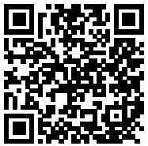 Website: 